VISION STATEMENT
To be globally recognized and at the forefront of innovation in higher education for empowering students and creating a seamless transition for all.

MISSION STATEMENT
To introduce and connect all new undergraduate students to Purdue University in West Lafayette and Indianapolis through student- and staff-led academic and social programming, both on campus and virtual, to prepare them for their Purdue experience.

PROGRAM ELEMENTS
The Orientation Programs office provides a series of experiences that facilitate the transition of undergraduate students to Purdue and opportunities for student leadership. New students going through Orientation Programs experiences are welcomed “All Aboard Purdue,” a four-step process to start their journey as Boilermakers.
- Purdue 101 (Step One) – This self-led virtual Brightspace module guides students through campus resources and provides information to help new beginners transition to Purdue's academics, advising processes, and academic support resources. Purdue 101 is available to summer- and fall-beginning students from May to late August, and January-beginning students from October to January. New students are automatically enrolled in this online orientation module and have access to the module through the end of their first semester. Students who complete the Student Information Form (SIF) are then invited to schedule an appointment with their academic advisor.
- Purdue Advising (Step Two) – Once Purdue 101 is complete, students receive an email from an academic advisor about scheduling their first advising appointment. Students fill out a course request form after they meet with their advisor.
- Purdue 102 (Step Three) – This self-led virtual Brightspace module focuses on resources related to students' transition to campus and adjustment to college life. Purdue 102 is available to summer- and fall-beginning students in June and spring-beginner students in early December. New students are automatically enrolled in this online orientation module and have access to the module through the end of their first semester.
- Purdue Welcome (Step Four) – Optional welcome programs for students in West Lafayette include Boiler Gold Rush, Boiler Gold Rush International (fall beginners) and Boiler Cold Rush (spring beginners). Students in Indianapolis can attend Boiler Gold Rush in Indianapolis (fall beginners). Students may alternatively participate in campus welcome programs hosted by the Purdue “All-American” Marching Band, Purdue Musical Organizations (Purdue Varsity Glee Club and Purduettes), and Athletics programs in West Lafayette. Orientation Programs facilitates the following programs:
  - Boiler Gold Rush (BGR) – Established in 1993 as CORN (Collegians Orientating Residential Newcomers) Camp and as Boiler Gold Rush in 1995, BGR is Purdue’s fall orientation program. BGR takes place inside and outside of the classroom the week before the fall term in August. This program is open to all new first-year and transfer students and was held in Indianapolis for the first time in 2024.
  - Boiler Gold Rush International (BGRi) – Established in 2012, BGRi is a supplemental program that supports the transition, adjustment and acculturation of international students in the days prior to Boiler Gold Rush. BGRi was held in Indianapolis for the first time in 2025.
  - Boiler Cold Rush (BCR) – Established in 2021, BCR is a multi-day program for students starting at Purdue during the spring semester.
- Summer Visit Days (Optional) – Established in 2022, these optional events in June are held for students and their families to visit campus and engage with current Purdue students and staff.
Program Overview Introduction
This Program Overview captures many significant accomplishments of the Orientation Programs team from fall 2024 through fall 2025. From key collaborations to important data findings, there are noticeable influences on the work that took place over the last year. Both an evolving landscape in Indianapolis, and concerns with international student visas, made significant impacts on the work of the Orientation Programs team over this time period.
Commitment to Collaboration Across Campus and in our Communities
The Orientation Programs team could not facilitate impactful experiences without the help and support of critical partners on campus and in our communities. Below are a few highlights of strong, unique collaborative partnerships that complement and support the work of orienting new students to campus:
- For the third year in a row, the Orientation Programs team worked with the Student Concert Committee (SCC) and Live Events and Production (LEAP) student organizations (through Purdue Convocations and Hall of Music Productions) to seek student bands and produce the Slayter Slam event during BGR in West Lafayette. The bands selected by SCC also performed at the White River State Park Concert for BGR in Indianapolis.
- For the third year in a row, the Orientation Programs team worked with the Purdue Student Union Board (PSUB) and Student Activities and Organizations (SAO) to put on events for the Fountain Fest event during BGR in West Lafayette. With funding provided by Purdue Federal Credit Union, PSUB organized activities for participants outside the fountain run.
- For the fourth year in a row, Orientation Programs and the Fusion Studio for Entertainment and Engineering collaborated to create the “BGR Entertainment Challenge.” With funding supported by both units, this seed-grant opportunity for faculty and students awarded five student- and faculty-led projects featured around campus during Boiler Gold Rush. This year’s installations were featured in both West Lafayette and Indianapolis for the first time. The projects and coordinators were:

Project Title | Project Coordinators
AI Immersive Photo Fusion | - Josh Polk, Assistant Professor of Practice, Computer Graphics Technology
Mixed Reality Laser Tag | - Julian Triveri, graduate student  - George Takahashi, Principle Visualization Scientist, Envision Center
Purdue Pete Unveiled | - Garam Kim, Assistant Professor, School of Aviation and Transportation Technology  - Ronald Sterkenburg, Professor of Aviation Technology, School of Aviation and Transportation Technology
Machine Learning: In Motion | - Prof. Frederick C. Berry, Engr., Professor, School of Engineering Technology  - Renee Murray, senior lecturer, Rueff School of Design, Art, & Performance
VR Human Physiology | - Ramses V. Martinez, Associate Professor, Edwardson School of Industrial Engineering and Weldon School of Biomedical Engineering  - Beatriz Castro, Instructor in Department of Biological Sciences, Team Lead of LearnerX Lab
- Financial support was provided from Orientation Programs to support the above BGR Entertainment Challenge projects, as well as events for the five Cultural Centers, each of which occurred during “Open House” blocks of time during BGR in West Lafayette.
- In partnership with University Undergraduate Academic Advising, students participating in Boiler Cold Rush, Boiler Gold Rush International and Boiler Gold Rush (in West Lafayette and Indianapolis) were reviewed to see if they had a full-time course load of courses. Students who did not were contacted through their BGR Team Leader and connected with an academic advisor to adjust their class schedules.

Ongoing Success in Indianapolis
Several elements of the new student experience in Indianapolis were expanded as the Orientation Programs team supported students there for the second time.
- Several unique opportunities arose for Orientation Programs to facilitate community connections for students in Indianapolis, including but not limited to: an Indy Eleven, Indiana Pacers, Indianapolis Indians, and Indiana Fever games.
- Two summer staff days were held to connect the West Lafayette and Indianapolis teams.
- The Orientation Programs team hosted multiple mid-semester “Boiler Meet Up” events for new students.
- The first class of Team Supervisors were hired in Indianapolis. These 10 mid-level student leaders were Team Leaders for the first BGR in Indianapolis in 2024.
- The second class of Team Leaders were hired in Indianapolis.
- The Orientation Programs team moved from the Engineering and Technology building, to the second floor of The Student Center.
- Several partners at IU-Indianapolis were critical to the success of Boiler Gold Rush in Indianapolis, including IU-Indianapolis Events and Conference Services, Campus Dining, Auxiliary Services, CrimsonCard, and Police Department.
- Throughout the week, several students interacted with community partners like the Indianapolis Motor Speedway, White River State Park, the Kurt Vonnegut Museum, the Indianapolis Zoo and Indiana Landmarks.
- New/revised events during the week of BGR and BGRi included:
  - Boiler Gold Rush International (BGRi): Held for the first time in Indianapolis, 70 students were oriented through programs and events that were financially supported by university leadership.
  - Dining & Meals: With both Purdue and IU-Indianapolis starting their semester at the same time in 2025, many dining and space reservations were shifted compared to 2024 to accommodate for the overlap in programming between BGR and IU-I’s “Bridge Week”. This included meals, of which some were held on the second floor of Tower.
  - Move-in: this was shifted one day earlier in the program compared to 2024, to allow students more time to settle before going to West Lafayette for the Kickoff event, held again on Tuesday of the program.
  - Wellness: With the distinct nature of offerings between the two locations, the 2025 Wellness session was unique to Indianapolis instead of livestreamed between locations as it was in 2024.
  - White River State Park Concert: Held for the first time, this event took place of the final “Boilermaker Block Party” event in 2024. Bands who had performed at the Slayter Slam event in BGR at West Lafayette earlier in the week performed here.

Fall 2024/Spring 2025: New Beginners, Boiler Cold Rush, First-Year Success Project
- In September 2024, nine Student Orientation Committee (SOC) members were selected to implement support Orientation Programs events in Indianapolis and West Lafayette.
- In November 2024, 152 West Lafayette Team Supervisors were selected to implement and support Boiler Gold Rush in their respective locations. In West Lafayette, 11 were selected for the second year in a row. 12 additionally were selected to support BGRi.
- In March 2025, 685 Team Leaders were selected to support Boiler Gold Rush in West Lafayette. 72 of these students were selected to support BGRi.
- The Teaching and Learning communication team continued the second year of the First-Year Success Project, focusing on a consistent “just-in-time” email communication plan that directed students to critical resources throughout the fall semester.
- 120 students participated in the fourth annual Boiler Cold Rush, held Jan. 10-11, 2025. 20 “Orientation Leaders” (Team Supervisors) were selected to come back to the spring semester early to support the program.
- There were over 400 spring new beginners in 2024 enrolled in Purdue 101 and 102, with over 150 students in the online Veterinary Nursing Distance Learning program.
- Data from Boiler Cold Rush participants (Section II, Chart 6) shows that these students continue to be retained at rates significantly higher than non-participating peers. In 2024, 90.91% of first-time, full-time students were retained from the first to the second semester, still significantly higher than peers. Notably, 100% of these students were retained in both 2022 and 2023. Historically, all new beginners and transfers were retained from spring to fall in 2023, and retention rates have remained above 90% since Boiler Cold Rush began in 2021. Prior to Boiler Cold Rush, first-to-second-semester retention for this population never exceeded 87% between 2018 and 2020.

Summer 2025: Purdue 101/102, Summer Visit Days
- Purdue 101 opened for both Indianapolis and West Lafayette summer & fall 2025 new beginners on May 2. Purdue 102 opened for summer new beginners on June 2 and fall new beginners on June 23 in both locations.
- Purdue 101 opened for both Indianapolis and West Lafayette spring 2025 new beginners on October 14. Purdue 102 opened for spring new beginners on December 16 in both locations
- Orientation Programs staff shared content with Purdue Polytechnic Institute statewide location coordinators and Veterinary Learning Distance Learning staff to allow them to utilize and adjust as it applies to their student populations.
- Two Summer Visit Days events were held on Friday, June 13, and Friday, June 20. This optional event had 1,675 student and guest registrants between the two days). The two dates were very similar in participation: 320 students with 552 guests (872 total) on June 13; and 310 students with 493 guests (803 total) on June 20.
- 51 students (previously hired as Team Leaders or Team Supervisors) were selected as “Summer Conductors” to support Summer Visit Days events.
- A variety of campus partners and colleagues contributed to the program’s success. Student Activities & Organizations; University Residences; Dining & Culinary; the Office of the Dean of Students; University Undergraduate Academic Advising; and many others were present to assist in the program's success.
- IT colleagues that oversee PREMIS software automatically enrolled students into Purdue 101 sections by college, into Purdue 102 modules by start term, and started Brightspace courses for each at both West Lafayette and Indianapolis locations.
- For the fifth year in a row, students were able to pin themselves on a “Purdue 101 Map,” created in tandem with colleagues from Geographic Information Systems (GIS). Over 5,600 students engaged in this map (compared to 9,877 in 2024, 9,263 in 2023 and 8,050 in 2022), which gave students the chance to select their academic college then place their pin around the world.
- For the fourth year in a row, incoming students were encouraged to complete Purdue 101 to support a donation to the ACE Campus Food Pantry, where one dollar per completion would be donated. In total, $6,024 was donated from Orientation Programs, UUAA, Basic Needs program, and the Vice Provost of Teaching and Learning (compared to 9,236 in 2024, 6,646 in 2023, 6,638 in 2022, and 5385 in 2021). Overall, 9,502 students finished Purdue 101 by completing the SIF on or before June 18 (compared to 11,653 on June 17, 2024; 10,936 on June 23, 2023, and 10,196 on June 24, 2022).
- Purdue 101 opened for summer and fall beginners on May 2, encouraging summer beginners to complete by June 9 and fall beginners to complete by June 16. Purdue 101 included content such as
- Purdue 102 opened for summer beginners on June 2 and fall beginners on June 23, encouraging final completion by August 1 for all students. Purdue 102 included content such as the myStrengths Assessment (the final step in the module), PERTS Growth Mindset and information about campus and community resources.
- Significant design improvements were made to both Purdue 101 and 102 to help students more clearly navigate the modules.
- The Orientation Programs team provided additional support to the team managing Brightspace so the platform was more inclusive of students in Indianapolis. This included renaming the “West Lafayette” login button to “West Lafayette / Indianapolis.”

Fall 2025: Boiler Gold Rush (BGR), Boiler Gold Rush International (BGRi)
- Two “BGR Live” sessions were pre-recorded and launched on Tuesday, Aug. 5, to prepare students for Boiler Gold Rush at both locations. 512 live viewers watched the West Lafayette session, with over 10,900 views total (down from 11,800 in 2024). 87 live viewers watched the Indianapolis session, with over 1,500 views total (down from 2,000 in 2024).
- In West Lafayette, BGRi preceded BGR and had 463 registrants. BGRi programming in West Lafayette took place Aug. 16- 18.
- Move-in for BGR in West Lafayette took place over four days, to continue to accommodate the large incoming class sizes. This took place from Aug. 16- Aug. 19.
- The BGR Kickoff event was live-streamed for the sixth year in a row, yielding 1,822 concurrent live viewers at its peak (down from 2,134 in 2024, and higher than 1,175 in 2023 and 1,815 in 2022) and over 10,000 total views. The BGRi Opening Ceremony was also live-streamed publicly, yielding 23 concurrent live viewers (down from 42 in 2024) and over 1,300 views (without prior communication about its live-stream).
- All large content sessions for BGR were held in Elliott Hall of Music and supported by Hall of Music Productions. Loeb Playhouse and several other smaller lecture rooms around campus were also used because of the high number of participants. Hall of Music supported each session.
- Purdue Promise hosted a pre-BGR orientation program for all incoming students for the second year in a row.
- Over $300,000 of fee waivers were provided to students who demonstrated financial need so they could attend Boiler Gold Rush at no or reduced costs. Additionally, 40 students attended Jump Start, a program where students work in the dining courts during BGR while participating in the program at no cost. Orientation Programs and Dining & Culinary share these costs to support student participation in the program.
- New/revised events during the week of BGR and BGRi included:
  - The Boilermaker Community Session: Held on Wednesday, Aug. 20 in Indianapolis and Thursday, Aug. 21 in West Lafayette, this session was hosted by the Division of Student Life and focused on involvement and engagement advice for new students.
  - Thursday Night Events: David Frost (illusionist) was featured for the first time on the Thursday night of BGR, in addition to the movie “Cars”, two updated offerings compared to 2024. The Women’s Volleyball match, held Thursday in 2024, was held on the final full day of move-in, Monday, Aug. 18.
  - BGRi Sendoff: Held on Monday, Aug. 18 in West Lafayette, this session served as a more formal transition from BGRi to BGR and included both students and family members. This year’s sendoff featured Brian Miller, a keynote speaker and magician.

Fall 2025 and Beyond
Several significant changes have already influenced the work of the Orientation Programs team, and will be much of the focus for the fall of 2025 and beyond:
- The first Student Orientation Committee with representation from both locations was hired in September 2025, and will support orientation efforts in both West Lafayette and Indianapolis.
- Conversations are ongoing to strategize for BGR program locations in Indianapolis, both for new spaces that have come online for 2026, and with the anticipated opening of the Academic Success Building in 2027.
- Critical conversations are ongoing to strategize for the loss of Elliott Hall of Music (construction) in 2026. This impacts most content-based sessions for BGR and the delivery method for that content to over 6,000 students (the seats lost with the unavailability of Elliott).
- With a higher targeted class of incoming students, the Orientation Programs team will maintain agility as it relates to its impacts on all aspects of the orientation process – from Purdue 101/Advising/102 completion statuses, to BGR/BGRi registration and event planning efforts.
Personal and Professional Accomplishments
- Arrivals / Departures
  - Abby Roskos, a program coordinator, completed her final day at Purdue on May 12, 2025, leaving to accept a role at the University of Nebraska-Lincoln as a Program Coordinator in the Center for Academic Success and Transition.
  - Jacque Rickett, was promoted to assistant director on July 1, 2025 to coordinate the office’s student staff experiences
- Staff had personal and professional achievements this year:
  - Craig Johnson was tapped as an honorary member of the Barbara Cook Chapter of Mortar Board at Purdue University on Nov. 7, 2024.
  - Virginia Johnson finished her studies in the College of Education at Purdue University, receiving a Master of Science in Education with a focus curriculum and instruction in Dec. 2024.
  - Alison Webb facilitated a keynote address on student development and sense of belonging at the Indiana Youth Institute's Youth Worker Café event in Elkhart, Indiana on Oct. 16, 2025
  - Maggie Smith taught “COM 217: Science Writing and Presentation” in both the Spring and Fall 2025 semesters
- Select staff members took part in notable professional development opportunities on campus:
  - Whitney Johnson presented at the 2025 Helen Bass Williams Academic Success Center Leadership Summit.
  - Jacque Rickett served as a panelist for a student support panel at the Daniels School of Business “Daniels Scholar Day” on February 22, 2025.
- Students and staff also had notable involvement at the NODA Region VII Conference in Waterloo, Ontario, Canada, held from March 28-30, 2025.
  - Conference Presentations:
    - Adina Loomis and Kendall DeVault presented "Knowing Me, Knowing You: How Adopting a Growth Mindset can teach you about Yourself and Others."
    - Grant Richmond and Michael Huang presented “Thank you for the Vulnerability: Cultivating Authentic Spaces throughout the Orientation Experience."
    - Amelia DeSanto and Eva Brandt presented "First Impressions, Lasting Impact."
    - Julian Kukor and Ryan Swiatlowski presented "Gimme! Gimme! Gimme! A Buddy!"
    - Carter Lone and Kayleigh Fulton presented "Prioritizing You: Self Care in Orientation Programs."
    - Abby Roskos and Adina Loomis presented "Here We Go Again: Building a Sustainable Online Orientation."
- Recognition:
    - Grant Richmond and Michael Huang won the Undergraduate Showcase Award for their presentation “Thank you for the Vulnerability: Cultivating Authentic Spaces throughout the Orientation Experience."
    - Kayleigh Fulton and Julian Kukor won their respective Case Study Competitions
    - Purdue won first place in the Banner Competition
- Volunteer Involvement:
    - Adina Loomis: Educational Sessions and Awards Planning Committee
    - Jacque Rickett: Undergraduate Programming Planning Committee
    - Hannah Keeler: Volunteer Case Study Judge
    - Whitney Johnson: Volunteer Case Study Judge
- Additional professional development highlights for the team include:
  - Craig Johnson and Alison Webb attended the 2025 Big Ten Meeting of orientation professionals from Sept. 29- Oct. 1, 2025, at the University of Minnesota-Twin Cities.
  - Maggie Smith virtually attended the “Applying the Quality Matters Rubric” Workshop, regarding online course design, on Oct. 23-24, 2025.
  - Virginia Johnson, Craig Johnson, Hannah Keeler, Adina Loomis, and Whitney Johnson attended the 2025 NODA Annual Conference in San Francisco, California, Oct. 24-27, 2025.
  - Virginia Johnson completed her second year as a faculty member for the Orientation Professionals Institute (OPI) through NODA, and co-facilitated this in-person experience prior to the NODA Annual Conference in San Francisco.
  - Craig Johnson was selected to be a faculty member for the Directors and Managers Institute (DMI) through NODA, and co-facilitated this in-person experience prior to the NODA Annual Conference in San Francisco.

OUR DATA
Student Participation Retention
- “The research on orientation clearly indicates that successful orientation programs have a powerful influence on first-year social and academic integration and, furthermore, that social and academic integration have a significant effect on student persistence and educational attainment” (Rode, 2000, p. 3).
  - Rode, D. (2000). The role of orientation in institutional retention. In M.J. Fabich (Ed.) Orientation planning manual 2000. Pullman, WA: NODA.
- This connection between orientation and retention is no different at Purdue University than what the research above suggests. As indicated by the charts listed in the Appendix (Section II, Student Participation Retention), retention and graduation rates for students who participate in STAR/VSTAR (now Purdue 101), BGR and/or BGRi are higher than their peers who do not participate.
- Additional data shows that participating in more than one program increases the likelihood of retention at a greater rate than non- or single-participating peers (Section II, Student Participation Retention, Chart 4).
Program Assessment
- Pre-post assessment methods were adopted to fully assess the impact of VSTAR, BGR and BGRi to further understand the impact of Orientation Programs on the new student experience. 10,706 (85.83%) participated in a pre-Purdue 101 survey, 11,135 (89.27%) participated in a post-Purdue 101 survey and 3,669 (37.95%) participated in a post-BGR/BGRi survey.
- Both campuses show an increase in Belonging mean scores across all items.
- PWL students started with slightly higher Belonging mean scores on most items and maintained consistent positive changes across all belonging areas, but PIN students show slightly larger gains on all items.
- Feeling valued and feeling accepted by the campus community shows greater increases for Black Boilermakers from post-Purdue 101 survey (Time 2) to post-BGR survey (Time 3) than for all other Boilermakers.
- Data was collected on session satisfaction by program and broken down by several demographics (college, ethnicity, gender, others) to develop a comprehensive understanding of the impact of Orientation Programs.
- Great strides were made in the relationship with IDA+A. Strengthening the work in this area will be a priority going into the coming year.

APPENDIX

Section I. Assessment Plan
- Orientation Programs distributes pre- and post-surveys at three different points in a new student’s transition to study sense of belonging, program satisfaction and meeting learning outcomes/office mission because of their participation in our programs. These surveys contribute to programmatic change, the ability to provide partners feedback on their student populations and insight into who staff need to focus on (first-generation, Black/African American students, neuro-diverse students, etc.).
  - The pre-survey is distributed in Purdue 101 in Brightspace and framed as required.
  - The mid-survey is distributed in Purdue 102 in Brightspace and encouraged. This also serves as the pre-BGR data point.
  - The post-BGR/i survey is distributed to all participants who checked into the program.
  - A short survey was sent to students who did not participate in BGR to garner feedback on barriers that prevented them from registering. For example, one barrier was the fee cost, so Orientation Programs focused more energy on communicating about fee waivers.
- Colleagues from IDA+A analyzed survey results across demographics, identities and academic colleges to measure differences among populations.
- Data was collected and shared with appropriate campus partners to help for future planning.

Section II. Student Participation Retention
The chart below indicates the number of students who participated in STAR, the number of students who participated in VSTAR and the number of students who registered for STAR but ultimately did not attend (all 2019 and prior). In 2020, that shifted to a VSTAR experience only. The VSTAR experience was rebranded as Purdue 101 in 2023 and is reflected in this chart. These populations are then followed throughout their Purdue experience to see at what rate they persist to graduation.

Chart 1: Retention and Graduation Rates for Summer Orientation
Cohort Year | Cohort | Original Cohort | 1 Year Retention | 2 Year Retention | 3 Year Retention | 4 Year Graduation | 5 Year Graduation | 6 Year Graduation
2014 | STAR | 4767 | 93.25% | 88.78% | 84.41% | 61.23% | 79.69% | 83.81%
2014 | VSTAR | 1432 | 92.32% | 87.08% | 84.50% | 57.89% | 79.54% | 83.59%
2014 | STAR No-Show | 125 | 88.80% | 79.20% | 72.00% | 55.20% | 66.40% | 68.00%
2015 | STAR | 5192 | 92.22% | 88.23% | 83.49% | 61.67% | 79.91% | 83.72%
2015 | VSTAR | 1481 | 90.68% | 84.40% | 81.84% | 57.19% | 76.77% | 81.16%
2015 | STAR No-Show | 106 | 85.85% | 84.91% | 79.25% | 56.60% | 73.58% | 79.25%
2016 | STAR | 5695 | 91.66% | 87.60% | 82.81% | 63.06% | 79.65% | 83.41%
2016 | VSTAR | 1419 | 91.75% | 87.67% | 84.71% | 62.09% | 80.69% | 84.92%
2016 | STAR No-Show | 46 | 91.30% | 76.09% | 69.57% | 50.00% | 65.22% | 69.57%
2017 | STAR | 5958 | 92.20% | 88.27% | 83.38% | 65.74% | 80.95% | 83.89%
2017 | VSTAR | 1440 | 90.97% | 86.11% | 82.50% | 62.64% | 80.00% | 84.17%
2017 | STAR No-Show | 100 | 92.00% | 87.00% | 80.00% | 59.00% | 75.00% | 82.00%
2018 | STAR | 6560 | 92.01% | 88.25% | 82.93% | 66.84% | 81.19% | 83.73%
2018 | VSTAR | 1708 | 89.93% | 84.54% | 81.97% | 62.30% | 78.98% | 83.14%
2018 | STAR No-Show | 55 | 90.91% | 83.64% | 76.36% | 54.55% | 70.91% | 74.55%
2019 | STAR | 5998 | 94.13% | 88.85% | 82.79% | 68.24% | 81.51% | 84.94%
2019 | VSTAR | 1708 | 92.68% | 87.06% | 82.55% | 64.70% | 82.32% | 85.95%
2019 | STAR No-Show | 54 | 85.19% | 79.63% | 72.22% | 64.81% | 77.78% | 79.63%
2020 | VSTAR | 8622 | 91.72% | 87.18% | 81.78% | 67.43% | 80.76%
2021 | VSTAR | 10106 | 90.75% | 86.85% | 81.76% | 68.48%
2022 | VSTAR | 9262 | 92.32% | 89.25% | 82.24%
2023 | Purdue 101 | 9200 | 92.98% | 89.66%
2024 | Purdue 101 | 11119 | 92.63%

Chart 2 – BGR Participant vs Non-BGR Participant Retention and Graduation Rates
The chart below indicates the number of students who participated in BGR and the number of students who did not attend. These populations, then, are followed throughout their Purdue experience to see at what rate they persist to graduation.
Academic Year | Cohort |  | One Year Retention | Two Year Retention | Three Year Retention | Four Year Graduation | Five Year Graduation | Six Year Graduation
2011 | BGR | 4684 | 91.27% | 86.02% | 82.75% | 52.39% | 75.73% | 80.36%
2011 | Non-BGR | 1976 | 88.92% | 80.36% | 76.67% | 49.34% | 70.55% | 74.90%
2012 | BGR | 5010 | 91.58% | 87.25% | 84.09% | 56.69% | 78.36% | 82.34%
2012 | Non-BGR | 1319 | 88.86% | 81.73% | 78.47% | 52.69% | 72.78% | 76.80%
2013 | BGR | 5163 | 93.07% | 88.57% | 84.72% | 58.92% | 79.20% | 83.38%
2013 | Non-BGR | 1156 | 90.66% | 83.74% | 78.03% | 56.75% | 73.44% | 77.10%
2014 | BGR | 5199 | 93.50% | 88.86% | 84.94% | 61.47% | 80.23% | 84.13%
2014 | Non-BGR | 1209 | 89.58% | 84.45% | 79.98% | 55.00% | 75.10% | 79.57%
2015 | BGR | 5784 | 92.44% | 88.11% | 83.96% | 61.27% | 79.89% | 83.80%
2015 | Non-BGR | 1071 | 88.05% | 82.73% | 77.78% | 56.68% | 74.60% | 78.90%
2016 | BGR | 5996 | 92.19% | 88.19% | 84.11% | 63.76% | 80.90% | 84.61%
2016 | Non-BGR | 1233 | 88.97% | 83.78% | 77.62% | 57.18% | 73.80% | 78.18%
2017 | BGR | 6153 | 92.62% | 88.62% | 84.56% | 66.07% | 81.62% | 84.92%
2017 | Non-BGR | 1395 | 88.96% | 84.16% | 76.56% | 60.36% | 76.20% | 79.00%
2018 | BGR | 6577 | 92.47% | 88.57% | 84.19% | 66.98% | 82.41% | 85.15%
2018 | Non-BGR | 1751 | 88.18% | 83.15% | 76.93% | 60.37% | 73.96% | 77.38%
2019 | BGR | 6444 | 94.44% | 89.25% | 84.14% | 67.44% | 82.40% | 86.16%
2019 | Non-BGR | 1567 | 89.85% | 82.64% | 74.86% | 63.18% | 75.49% | 78.24%
2020 | BGR | 6447 | 93.36% | 89.48% | 84.15% | 70.33% | 83.53%
2020 | Non-BGR | 2331 | 86.66% | 79.97% | 74.52% | 58.39% | 72.46%
2021 | BGR | 7979 | 92.22% | 88.67% | 84.05% | 70.79%
2021 | Non-BGR | 2163 | 85.02% | 79.75% | 72.91% | 59.22%
2022 | BGR | 7646 | 92.79% | 90.27% | 83.51%
2022 | Non-BGR | 1629 | 89.81% | 84.28% | 76.12%
2023 | BGR | 7745 | 93.74% | 90.95%
2023 | Non-BGR | 1477 | 88.22% | 82.46%
2024 | BGR (WL) | 8884 | 93.79%
2024 | Non-BGR (WL) | 1662 | 88.93%
2024 | BGR (INDY) | 583 | 87.48%
2024 | Non-BGR (INDY) | 160 | 78.75%

Chart 3 – BGRi Participant vs Non-BGRi Participant Retention and Graduation Rates for International Students
The chart below indicates the number of students who participated in BGRi and the number of international students who did not attend. These populations, then, are followed throughout their Purdue experience to see at what rate they persist to graduation.
Academic Year | Cohort |  | One Year Retention | Two Year Retention | Three Year Retention | Four Year Graduation | Five year Graduation | Six Year Graduation
2012 | BGRi | 316 | 91.77% | 86.71% | 83.54% | 55.06% | 79.75% | 82.91%
2012 | Non-BGRi | 691 | 91.46% | 86.11% | 83.94% | 55.72% | 77.86% | 82.63%
2013 | BGRi | 497 | 94.57% | 89.94% | 87.53% | 61.77% | 82.29% | 85.31%
2013 | Non-BGRi | 482 | 92.53% | 84.44% | 80.29% | 55.39% | 74.69% | 79.46%
2014 | BGRi | 620 | 96.13% | 92.74% | 89.52% | 65.00% | 85.48% | 89.19%
2014 | Non-BGRi | 525 | 89.33% | 82.86% | 81.14% | 53.52% | 76.19% | 80.00%
2015 | BGRi | 716 | 93.85% | 87.99% | 85.89% | 58.80% | 80.84% | 84.62%
2015 | Non-BGRi | 346 | 84.97% | 78.32% | 76.59% | 56.65% | 72.25% | 77.17%
2016 | BGRi | 635 | 93.39% | 89.76% | 87.87% | 64.40% | 85.20% | 88.50%
2016 | Non-BGRi | 305 | 89.51% | 85.57% | 80.98% | 59.18% | 74.10% | 79.67%
2017 | BGRi | 624 | 93.59% | 89.90% | 86.06% | 66.35% | 84.29% | 88.30%
2017 | Non-BGRi | 264 | 87.12% | 83.71% | 80.30% | 60.23% | 77.65% | 83.33%
2018 | BGRi | 513 | 92.98% | 86.74% | 87.72% | 61.99% | 83.04% | 86.74%
2018 | Non-BGRi | 280 | 85.00% | 80.36% | 79.64% | 56.07% | 73.57% | 80.71%
2019 | BGRi | 741 | 92.71% | 87.72% | 85.83% | 61.00% | 82.46% | 87.24%
2019 | Non-BGRi | 316 | 88.92% | 81.01% | 81.01% | 58.23% | 75.32% | 81.96%
2020 | BGRi | 388 | 90.98% | 88.40% | 86.08% | 61.86% | 81.44%
2020 | Non-BGRi | 478 | 86.82% | 81.38% | 79.50% | 53.56% | 69.87%
2021 | BGRi | 412 | 92.48% | 87.86% | 84.22% | 69.17%
2021 | Non-BGRi | 435 | 89.43% | 82.07% | 79.08% | 58.85%
2022 | BGRi | 374 | 92.51% | 90.37% | 90.11%
2022 | Non-BGRi | 382 | 90.05% | 87.17% | 84.55%
2023 | BGRi | 464 | 91.81% | 88.79%
2023 | Non-BGRi | 270 | 83.33% | 81.48%
2024 | BGRi | 622 | 93.25%
2024 | Non-BGRi | 289 | 87.20%

Chart 4 – Orientation Programs Participant Levels (zero, one, or two programs) and their Retention and Graduation Rates
The chart below indicates the number of students who participated in a combination of Orientation Programs during a given year. Students who participated in both summer and fall programs are highlighted in three ways: “STAR+BGR”, “VSTAR+BGR”, and “VSTAR+BGRi”. Students who participated in STAR and not BGR or BGRi but did participate in another pre-arrival event (Purdue Musical Organizations, All-American Marching Band, and Intercollegiate Athletics) are indicated with “STAR no BGR/i”. Students who participated in STAR or VSTAR but did not participate in any pre-arrival event in Orientation Programs or other units are indicated with “STAR no Other Program” and “VSTAR no Other Program.” Starting with data from 2023, the renaming of STAR/VSTAR to Purdue 101 will be reflected in this chart.
Academic Year | Cohort |  | One Year Retention | Two Year Retention | Three Year Retention | Four Year Graduation | Five year Graduation | Six Year Graduation
2015 | STAR+BGR | 4489 | 92.40% | 88.53% | 83.94% | 62.01% | 80.15% | 84.01%
2015 | VSTAR+BGR | 1181 | 92.97% | 86.54% | 83.83% | 58.25% | 78.83% | 82.98%
2015 | VSTAR+BGRi | 705 | 94.04% | 88.23% | 85.82% | 58.58% | 80.71% | 84.68%
2015 | STAR no BGR/i | 235 | 95.74% | 92.77% | 88.09% | 61.28% | 85.53% | 88.51%
2015 | VSTAR no BGR/i | 17 | 82.35% | 94.12% | 82.35% | 64.71% | 82.35% | 82.35%
2015 | STAR no Other Program | 468 | 88.68% | 83.12% | 76.92% | 58.55% | 74.79% | 78.63%
2015 | VSTAR no Other Program | 283 | 81.63% | 74.91% | 73.50% | 52.65% | 68.20% | 73.50%
2016 | STAR+BGR | 4814 | 92.02% | 88.10% | 83.65% | 63.88% | 80.43% | 84.17%
2016 | VSTAR+BGR | 1121 | 92.77% | 88.85% | 86.35% | 63.78% | 83.23% | 86.89%
2016 | VSTAR+BGRi | 641 | 93.29% | 90.02% | 88.14% | 64.74% | 85.18% | 88.46%
2016 | STAR no BGR/i | 210 | 92.86% | 89.05% | 83.33% | 57.62% | 80.48% | 82.86%
2016 | VSTAR no BGR/i | 16 | 100.00% | 100.00% | 87.50% | 56.25% | 87.50% | 93.75%
2016 | STAR no Other Program | 671 | 88.67% | 83.61% | 76.60% | 58.87% | 73.77% | 78.09%
2016 | VSTAR no Other Program | 282 | 87.23% | 82.27% | 78.01% | 55.67% | 70.21% | 76.60%
2017 | STAR+BGR | 4966 | 92.65% | 88.96% | 84.53% | 66.45% | 81.68% | 84.72%
2017 | VSTAR+BGR | 1111 | 92.35% | 87.13% | 84.70% | 64.72% | 81.64% | 85.87%
2017 | VSTAR+BGRi | 641 | 93.45% | 89.86% | 86.43% | 66.30% | 83.93% | 88.14%
2017 | STAR no BGR/i | 269 | 91.82% | 87.36% | 83.27% | 61.71% | 82.90% | 84.39%
2017 | VSTAR no BGR/i | 27 | 92.59% | 88.89% | 85.19% | 66.67% | 85.19% | 85.19%
2017 | STAR no Other Program | 723 | 89.21% | 83.82% | 75.52% | 62.38% | 75.24% | 78.01%
2017 | VSTAR no Other Program | 302 | 85.76% | 82.12% | 74.17% | 54.64% | 73.51% | 77.81%
2018 | STAR+BGR | 5263 | 92.57% | 89.13% | 84.08% | 67.93% | 82.60% | 85.10%
2018 | VSTAR+BGR | 1277 | 92.09% | 86.30% | 84.65% | 63.35% | 81.60% | 85.43%
2018 | VSTAR+BGRi | 533 | 92.87% | 86.49% | 87.62% | 61.73% | 82.74% | 86.68%
2018 | STAR no BGR/i | 290 | 94.48% | 91.72% | 87.59% | 66.21% | 81.72% | 84.14%
2018 | VSTAR no BGR/i | 68 | 86.76% | 79.41% | 64.71% | 60.29% | 75.00% | 76.47%
2018 | STAR no Other Program | 1007 | 88.38% | 82.62% | 75.57% | 61.37% | 73.68% | 76.46%
2018 | VSTAR no Other Program | 363 | 82.92% | 79.34% | 75.76% | 54.27% | 70.52% | 76.58%
2019 | STAR+BGR | 4876 | 94.97% | 90.03% | 84.45% | 68.79% | 82.59% | 86.32%
2019 | VSTAR+BGR | 1388 | 93.52% | 88.04% | 83.72% | 65.35% | 83.50% | 86.96%
2019 | VSTAR+BGRi | 691 | 93.78% | 89.00% | 86.40% | 63.39% | 84.52% | 88.96%
2019 | STAR no BGR/i | 351 | 92.02% | 84.90% | 78.35% | 62.96% | 76.92% | 78.92%
2019 | VSTAR no BGR/i | 51 | 90.20% | 90.30% | 76.47% | 64.71% | 84.31% | 88.24%
2019 | STAR no Other Program | 771 | 89.75% | 83.14% | 74.32% | 67.19% | 76.78% | 78.99%
2019 | VSTAR no Other Program | 269 | 88.85% | 81.41% | 77.70% | 61.34% | 75.09% | 80.30%
2020 | VSTAR+BGR | 6359 | 93.38% | 89.57% | 84.24% | 70.48% | 83.58%
2020 | VSTAR+BGRi | 445 | 91.24% | 88.76% | 85.62% | 62.92% | 81.35%
2020 | VSTAR no BGR/i | 255 | 92.94% | 87.84% | 82.35% | 64.31% | 80.00%
2020 | VSTAR no Other Program | 2007 | 86.30% | 79.52% | 73.89% | 58.05% | 71.90%
2021 | VSTAR+BGR | 7967 | 92.26% | 88.70% | 84.08% | 70.87%
2021 | VSTAR+BGRi | 483 | 92.55% | 88.41% | 84.89% | 69.77%
2021 | VSTAR no BGR/i | 288 | 91.67% | 87.85% | 85.07% | 65.97%
2021 | VSTAR no Other Program | 1851 | 84.12% | 78.71% | 71.26% | 58.62%
2022 | VSTAR +BGR | 7640 | 92.84% | 90.30% | 83.55%
2022 | VSTAR + BGRi | 471 | 92.99% | 90.87% | 89.17%
2022 | VSTAR no BGR/i | 223 | 92.83% | 90.58% | 83.86%
2022 | VSTAR no Other Program | 1399 | 89.42% | 83.27% | 74.84%
2023 | Purdue 101 + BGR | 7742 | 93.74% | 90.96%
2023 | Purdue 101 + BGRi | 566 | 92.05% | 89.22%
2023 | Purdue 101 no BGR/i | 273 | 93.77% | 83.15%
2023 | Purdue 101 no Other Program | 1185 | 87.85% | 82.70%
2024 | Purdue 101 + BGR | 8773 | 93.76%
2024 | Purdue 101 + BGRi | 727 | 93.54%
2024 | Purdue 101 no BGR/i | 273 | 88.64%
2024 | Purdue 101 no Other Program | 2073 | 88.37%

Chart 5 – Summer Visit Days Retention and Graduation Rates
The chart below indicates the number of students who participated in Summer Visit Days and the number of students who did not attend. These populations, then, are followed throughout their Purdue experience to see at what rate they persist to graduation.
Academic Year | Cohort |  | One Year Retention | Two Year Retention | Three Year Retention | Four Year Graduation | Five year Graduation | Six Year Graduation
2022 | Summer Visit | 534 | 92.51% | 90.45% | 83.33%
2022 | No Visit | 8741 | 92.25% | 89.14% | 82.14%
2023 | Summer Visit | 283 | 92.23% | 87.99%
2023 | No Visit | 8939 | 92.87% | 89.39%
2024 | Summer Visit | 572 | 94.76%
2024 | No Visit | 10717 | 92.41%

Chart 6 – Boiler Cold Rush Retention and Graduation Rates
The chart below indicates the number of students who participated in Boiler Cold Rush and the number of students who did not attend. The first chart reflects first-time full-time students, the second reflects transfer students, and the third reflects all new beginners and transfers. These populations, then, are followed throughout their Purdue experience to see at what rate they persist to graduation.
The BCR step charts include only new and transfer students by Spring profile year, resulting in smaller counts due to factors like differing admissions populations, profile year misalignment for regional transfers, part-time starts, or Fall profile years with Spring starts. Transfer students are typically excluded from retention/graduation trends, which focus on first-time, full-time students. Similarly, retention-related BGR data shows slightly lower counts than actual attendees due to these criteria.

New Beginners (First-Time Full-Time) – PWL Only
Profile Semester | Cohort |  | 1 Sem. Ret. | 2 Sem. (1 Yr) Ret. | 3 Sem.Ret. | 4 Sem. (2 Yr) Ret. | 5 Sem. Ret. | 6 Sem. (3 Yr) Ret. | 7 Sem. Grad. | 8 Sem. (4 Yr) Grad.
Spring 2018 | No BCR | 51 | 88.24% | 86.27% | 86.27% | 84.31% | 84.31% | 80.39% | 41.18% | 56.86%
Spring 2019 | No BCR | 65 | 87.69% | 83.08% | 76.92% | 73.85% | 73.85% | 64.62% | 26.15% | 41.54%
Spring 2020 | No BCR | 55 | 92.73% | 92.73% | 85.45% | 81.82% | 76.36% | 74.55% | 40.00% | 52.73%
Spring 2021 | BCR | 25 | 92.00% | 92.00% | 84.00% | 76.00% | 76.00% | 76.00% | 44.00% | 64.00%
Spring 2021 | No BCR | 60 | 86.67% | 78.33% | 68.33% | 66.67% | 70.00% | 61.67% | 26.67% | 36.67%
Spring 2022 | BCR | 47 | 100.00% | 89.36% | 87.23% | 80.85% | 78.72% | 70.21% | 36.17%
Spring 2022 | No BCR | 83 | 86.75% | 83.00% | 79.52% | 74.70% | 69.88% | 68.67% | 33.73%
Spring 2023 | BCR | 24 | 100.00% | 91.67% | 87.50% | 79.17% | 79.17%
Spring 2023 | No BCR | 56 | 92.86% | 78.57% | 76.79% | 66.07% | 67.86%
Spring 2024 | BCR | 22 | 90.91% | 81.82% | 77.27%
Spring 2024 | No BCR | 61 | 85.25% | 75.41% | 70.49%
Spring 2025 | BCR | 46 | 89.13%
Spring 2025 | No BCR | 61 | 85.25%
Transfers (New and Regional Campus Transfers)
Profile Semester | Cohort |  | 1 Sem. Ret. | 2 Sem.  (1 Yr) Ret. | 3 Sem.Ret. | 4 Sem.  (2 Yr) Ret. | 5 Sem. Ret. | 6 Sem.  (3 Yr)  Ret. | 7 Sem. Grad. | 8 Sem.  (4 Yr) Grad.
Spring 2018 | No BCR | 238 | 83.61% | 76.05% | 71.01% | 63.03% | 39.08% | 22.27% | 58.82% | 58.82%
Spring 2019 | No BCR | 192 | 87.50% | 79.17% | 71.35% | 60.42% | 40.10% | 27.60% | 54.68% | 58.85%
Spring 2020 | No BCR | 184 | 79.89% | 71.74% | 63.04% | 57.07% | 36.96% | 25.00% | 51.08% | 54.89%
Spring 2021 | BCR | 34 | 88.24% | 82.35% | 85.29% | 76.47% | 38.24% | 26.47% | 82.35% | 85.29%
Spring 2021 | No BCR | 235 | 78.30% | 71.91% | 63.40% | 54.89% | 37.02% | 26.38% | 51.92% | 56.17%
Spring 2022 | BCR | 39 | 95.12% | 95.12% | 85.37% | 73.17% | 46.34% | 29.27% | 80.49%
Spring 2022 | No BCR | 182 | 81.32% | 76.37% | 70.33% | 62.64% | 40.66% | 31.87% | 53.30%
Spring 2023 | BCR | 38 | 100.00% | 100.00% | 89.47% | 76.32% | 44.74%
Spring 2023 | No BCR | 221 | 90.05% | 84.62% | 76.47% | 67.42% | 45.70%
Spring 2024 | BCR | 47 | 95.74% | 91.49% | 91.49%
Spring 2024 | No BCR | 267 | 86.52% | 80.15% | 65.17%
Spring 2025 | BCR | 41 | 90.24%
Spring 2025 | No BCR | 241 | 77.59%

All New Beginners & Transfers
Profile Semester | Cohort |  | 1 Sem. Ret. | 2 Sem. (1 Yr) Ret. | 3 Sem.Ret. | 4 Sem. (2 Yr) Ret. | 5 Sem. Ret. | 6 Sem. (3 Yr) Ret. | 7 Sem. Grad. | 8 Sem. (4 Yr) Grad.
Spring 2018 | No BCR | 296 | 83.78% | 77.03% | 72.97% | 66.22% | 49.96% | 32.09% | 54.73% | 57.44%
Spring 2019 | No BCR | 263 | 87.07% | 80.23% | 73.38% | 64.26% | 49.05% | 38.02% | 46.39% | 53.23%
Spring 2020 | No BCR | 253 | 82.21% | 74.70% | 66.40% | 60.47% | 45.45% | 36.36% | 46.25% | 51.78%
Spring 2021 | BCR | 58 | 91.38% | 87.93% | 86.21% | 77.59% | 55.17% | 48.28% | 67.24% | 77.59%
Spring 2021 | No BCR | 318 | 76.42% | 69.50% | 60.69% | 54.26% | 41.64% | 31.86% | 43.85% | 54.89%
Spring 2022 | BCR | 88 | 97.73% | 92.05% | 86.36% | 77.27% | 63.64% | 51.14% | 56.82%
Spring 2022 | No BCR | 281 | 80.07% | 76.16% | 70.82% | 65.12% | 48.75% | 42.70% | 45.20%
Spring 2023 | BCR | 63 | 100.00% | 95.24% | 87.30% | 76.19% | 57.14%
Spring 2023 | No BCR | 292 | 88.70% | 81.51% | 73.97% | 64.73% | 48.63%
Spring 2024 | BCR | 69 | 94.20% | 88.41% | 86.96%
Spring 2024 | No BCR | 363 | 84.34% | 77.13% | 63.09%
Spring 2025 | BCR | 88 | 89.77%
Spring 2025 | No BCR | 325 | 79.92%

Chart 7 – BGR/BGRi Attendance
The charts below indicate the overall number of admits that participated in BGR/BGRi (New First Time & Transfer Admits) and percentage of admits by population. For the first time in Indianapolis, BGR hosted 72% of all admits. In West Lafayette, 77.8% of new first time and transfer admits participated in BGR/BGRi, the fifth highest number since 2014. Transfer student participation in West Lafayette fell in 2024 to 18.6% from 22.7% in 2023 but was the fourth highest since 2014.

Indianapolis Percent of BGRi Attendance for International Students (First Year of BGRi)
Year | Campus | Percent of International Admits
2025 | INDY | 50.93%

Chart 8 – BCR Attendance

The charts below indicate the overall percentage of admits that participated in BCR (New First Time & Transfer Admits) and percentage of all New First Time & Transfer admits.

Chart 9 – Summer Visit Days
The chart below indicate the number of students, guests, and overall percentage of admits that participated in Summer Visit days.

Section III. Program Assessment
To further understand students’ experience across programs, a pre-post assessment method was adopted to fully assess the impact of the orientation experience on students’ satisfaction, learning outcomes, and sense of belonging. These can be viewed through three points of data collection: Pre-Purdue 101, Post-Purdue 101 (also considered to be Pre-BGR), and Post-BGR.
The participation rate of each survey can be seen below:
Year | Campus | Pre-Purdue 101  (% of participants) | Post-Purdue 101  (% of participants) | Post-BGR  (% of participants)
2018 | PWL | 2,262 (35.8%; pre-STAR) | 5,558 (88.3%; post-STAR) | 3,208 (56.1%; post-BGR)
2019 | PWL | 2,736 (47.8%; pre-STAR) | 4,326 (76.0%; post-STAR) | 2,844 (55.8%; post-BGR)
2020 | PWL | 7,557 (87.9%; pre-VSTAR) | 4,817 (56.9%; post-VSTAR) | 2,894 (44.9%; post-BGR)
2021 | PWL | 8,316 (86.7%; pre-VSTAR) | 5,300 (55.4%; post-VSTAR) | 3,491 (45.9%; post-BGR)
2022 | PWL | 9,156 (93.9%; pre-VSTAR) | 6,824 (70.0%; post-VSTAR) | 3,193 (40.3%; post-BGR)
2023 | PWL | 9,374 (95.5%; pre-Purdue 101) | 7,633 (77.8%; post-Purdue 101) | 3,850 (48.7%; post-BGR)
2024 | PWL | 10,009 (85.6%; pre-Purdue 101) | 10,464 (89.5%; post-Purdue 101) | 3,443 (37.9%; post-BGR)
2024 | INDY | 697 (88.6%; pre-Purdue 101) | 671 (85.3%; post-Purdue 101) | 226 (38.1%; post-BGR)
2025 | PWL | 9,467 (95.42%; pre-Purdue 101) | 8,953 (90.24%; post-Purdue 101) | 3,862 (48.72%; post-BGR)
2025 | INDY | 629 (82.22%; pre-Purdue 101) | 650 (85%; post-Purdue 101) | 315 (60.23%; post-BGR)

The overall satisfaction rate (Very Satisfied + Satisfied on a five-point Likert scale) can be seen below for each program:
Year | Campus | Purdue 101 | Boiler Gold Rush | Boiler Gold Rush International
2021 | PWL | 88.9% | 82.9% | 72.8%
2022 | PWL | 83.6% | 83.4% | 89.5%
2023 | PWL | 86.5% | 86.3% | 84.4%
2024 | PWL | 84.8% | 82.9% | 91.8%
2024 | INDY | 80.0% | 87.1% | N/A
2025 | PWL | 85.6% | 86.77% | 89.74%
2025 | INDY | 83.8% | 89.81% | 90.63%

Section IVa. Engagement and Retention, Website
The following data is gathered for purdue.edu/orientation from Google Analytics 4, a data-tracking website used to learn about website performance, user demographics and more. In many places, data is taken from a small percentage of users, who may or may not accurately represent the whole dataset.
All data was collected between Sep. 1, 2023, and Sep. 1, 2024.
The report is broken up into three main sections:
- Website Usage
  - These are general statistics about the total numbers of website users, page views, session times and more. Generally, these reveal large trends across the site, such as popular times for the site throughout the year and how users interact with the site on a basic level.
  - This section also discusses which pages on the site are most popular, which is particularly interesting for noting the success/failure of newly created pages.
- User Demographics
  - This section explores the types of users on the website with categories such as age, gender and geolocation. This section is particularly interesting for sites with very particular expected audiences, such as “undergraduate students in West Lafayette,” because expected versus actual audiences can be explored.
- Technology
  - This section shares information about the types of devices and browsers that users are utilizing. This can be helpful for web development and design purposes because it reveals which devices to test the website more extensively on.
- Acquisition
  - This section shows the ways in which users reach the website, such as via a social media post or an email.

Website Usage, General Overview
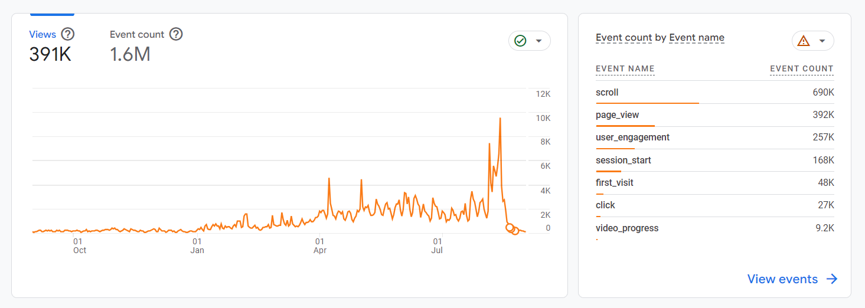

Notable Data Points
- In 2023-24, there was a clear rise in website usage beginning in the spring and reaching its peak during early August. This is very expected on the Purdue Orientation website, given the nature and timing of its fall programming. Several spikes are seen throughout the early summer, likely corresponding to email campaigns.
  - Users spent an average of 2m 09s on the website in 2023-24, almost exactly as long as the average time spent on Purdue websites as a whole (2m 08s). This helps us to know that we are aligning our web design and development with the Purdue ecosystem.
- New data allows us to determine that, on average, Orientation website users engaged in roughly 4.1 ‘events per session’, where an event is qualified as any kind of direct interaction with the web page, such as: scrolling, clicking, downloading, and more (see rightmost graphic above for full list)
  - This is higher than the Purdue-wide number of events per session, which sits at 3.5 for 2023-24, suggesting that users are more likely to engage with the Orientation website than other Purdue websites, on average
- On the whole, the Orientation website began experiencing an increase in overall engagement (page views, clicks, user visits, etc.) in March, and a rapid decrease beginning late August. This will help us in future years to know when we ought to begin updating information about fall orientation.

Website Usage: Popular Pages
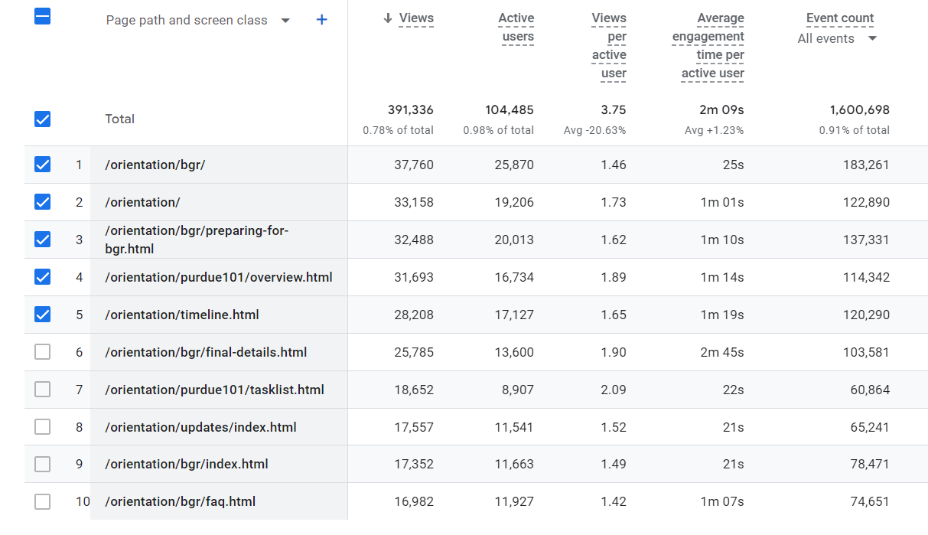
The chart pictured above shows the ten most viewed pages associated with the URL “purdue.edu/orientation/.” It is important to note that the second item, listed simply as “/orientation/.” indicates the website’s home page. This is the same page as item #9, listed as “/orientation/index.html.”
Notable Data Points
- Popular pages experienced several small shifts from 2022-23 to 2023-24, most notably:
  - A slight increase in Purdue 101 traffic: “Purdue 101 Overview” up to #4 from #8 last year and “NST” up to #7 from #10 last year.
  - A rise in the popularity of the main “Home” page, up to #2 from #5 last year.
  - The appearance of our “Orientation Timeline” page, which did not make the top 10 pages last year.

Website Usage: User Demographics
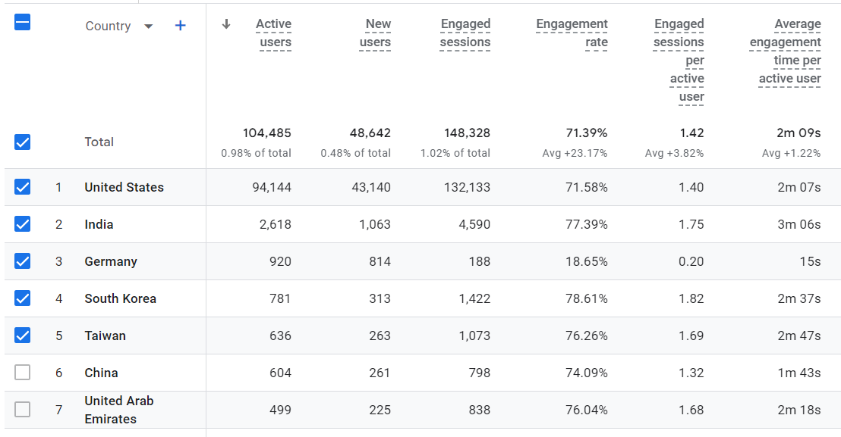

Notable Data Points
- With the update to GA4, the ability to track age and gender was lost.
- Other demographic data is unsurprising, as the most popular language (around 97%) was English, and the most popular country of viewership was the United States
  - One interesting point is that, in the Purdue ecosystem, Canadian viewers make up the second highest percentage of viewers, while they barely crack the top 10 on the Orientation website (#8 highest percentage).

Website Usage: Technology Usage
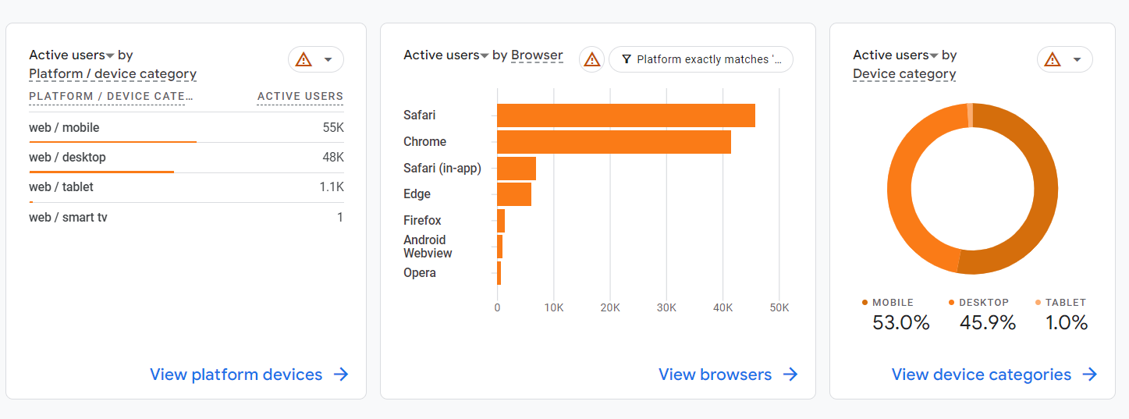
The leftmost graphic provides the total number of users who preferred each device type (desktop, mobile, or tablet), while the rightmost graphic provides the same information in percentages.
The center chart lists the most popular browsers for users on the Orientation website, listed from most popular (top) to least popular (bottom)
Notable Data Points
- Orientation programs continues to hover around the 50/50 mark in terms of mobile vs. desktop viewers, leaning slightly less mobile this year than last (53% mobile / 46% desktop in 2023-24 vs. 55% mobile / 43% desktop in 2022-23). A less-than-half number of desktop viewers highlights our need to revisit mobile usability on the website throughout the year, and to consider it throughout the process of building new pages.
- Safari continues to sit at the top of the list for browser popularity, yet we remain unable to test our websites on Safari due to Purdue staff technology (e.g., Purdue uses Windows machines, which are unable to run Safari without additional administrative support). This may be an issue for web and UX design.
  - It is also worth noting that Purdue has stopped providing support for Chrome in many of its internal products due to security risks. I do not recommend that we stop using Chrome in our website building/testing due to its popularity.

Traffic and User Acquisition: General Overview
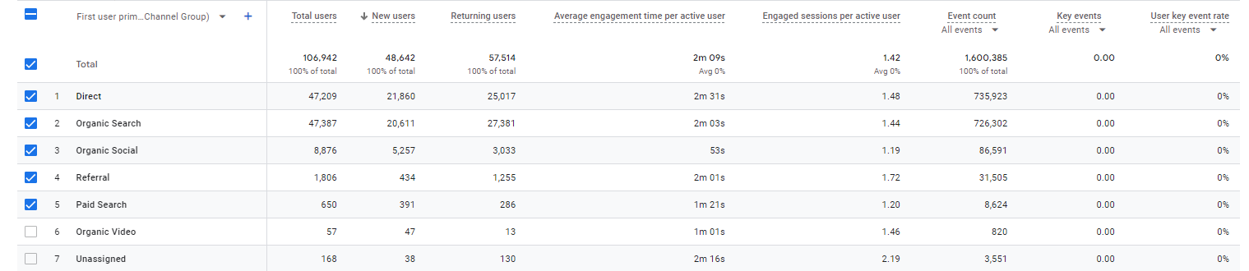

“Organic Search” refers to users who found the site via a search engine (e.g. Google, Bing, Yahoo). “Direct” refers to users who came to the site via directly typing the link directly into their browser, had the site bookmarked, or came via a link in a PDF / Word Doc. “Referral” refers to users who came to the site via a link on another website. “Email” refers to users who came to the site via a link from an email (this number is extremely unreliable because these users are often lumped into other categories such as “Referral” or “Direct”). “Organic Social” refers to users who came to the site via a link on a social media platform
Notable Data Points
- The Orientation Programs website has a shockingly high number of users who arrive at the website via “Direct” acquisition, meaning that users typed in the URL of the website directly into their browser, had the page bookmarked, or came from a document such as a PDF or Word Doc. It is extremely rare that so many people would arrive “directly,” and this implies that many users either bookmark or memorize the URL of several orientation pages.
  - This is a very positive sign for our URL naming conventions, implying that they are easy to remember and easy to type.
- “Organic Social” continues to sit high on the list of user acquisition (#3 from 2022-24), much higher than other Student Success Programs websites
  - This is a positive sign for the social media team within Orientation, showing that their posts are being heavily engaged with and leading users to the main website.

Traffic and User Acquisition: Specific Sources
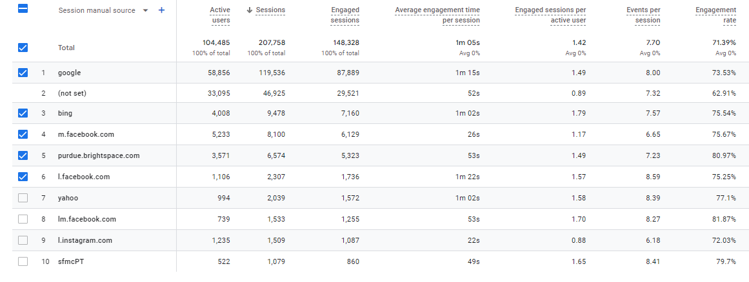

“(not set)” implies that GA4 was unable to determine how a user arrived at the specified website. In this case, it refers to the Orientation website. At this time, it is unclear what “smfcPT” refers to.

Section IVb. Engagement and Retention, Social Media

Orientation Programs Social Media Channels
Continued efforts were made on social media channels to increase followership and engagement, most notably through Instagram.
Platform | Program Overview 2020 | Program Overview 2021 | Program Overview 2022 | Program Overview 2023 | Program Overview 2024 | Program Overview 2025
Instagram | ~4,000 followers and 131 posts | 8,622 followers and 213 posts | 12,000+ followers and 217 posts (some archived) | ~14,000 followers and 276 posts (some archived) | ~17,700 followers and 338 posts (some archived) | ~20,800 followers and 389 posts (some archived
Facebook | ~1,700 likes and ~2,500 followers | 3,189 likes and 4,340 followers | 4,200+ likes and 5,719 followers | Currently inactive as forced by Facebook | 62 likes and 113 followers; used only for activity in the Parent & Family Facebook group | 114 followers; dormant with Parent & Family Connections shift to portal
YouTube | 922 subscribers and 58 videos | 1,530 subscribers and 76 videos | 1,890 subscribers | 2,260 subscribers | 3,240 subscribers | 4,135 subscribers




